Develop Object Detection and Video Processing Application using YOLO Model.

By,
S Hariharan
OBJECTIVE:
Develop a Video processing Application using YOLO Model with the help of Roboflow Platform.
Note: Try to create your own Dataset / Customize the existing dataset.

INTRODUCTION: ROBOFLOW


Roboflow empowers developers to build their own computer vision applications, no matter their skillset or experience. We expedite the procedure from data labeling to model training.
We experienced personally how laborious it might be to train and implement a computer vision model after developing our own apps. To format our data, we found ourselves creating a lot of extra code. Working together was challenging, and there was a lot of labor involved in benchmarking machine learning technologies.
We introduced Roboflow in January 2020 for this reason. We think computer vision ought to be a part of every developer's toolbox. Our goal is to take down any obstacles that could stand in their way.

OBJECT DETECTION:
Object detection is a computer vision task that involves identifying and locating objects in images or videos. It is a crucial component of numerous applications, including robotics, self-driving automobiles, and surveillance. Single-shot detectors and two-stage detectors are the two primary categories into which object detection algorithms fall.
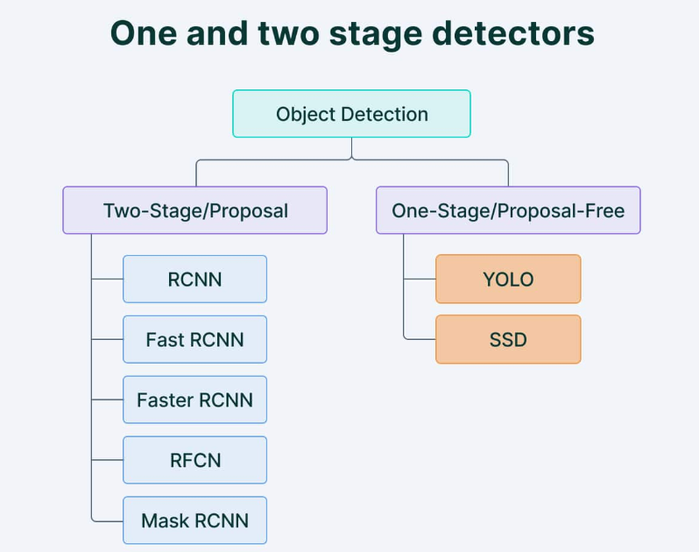

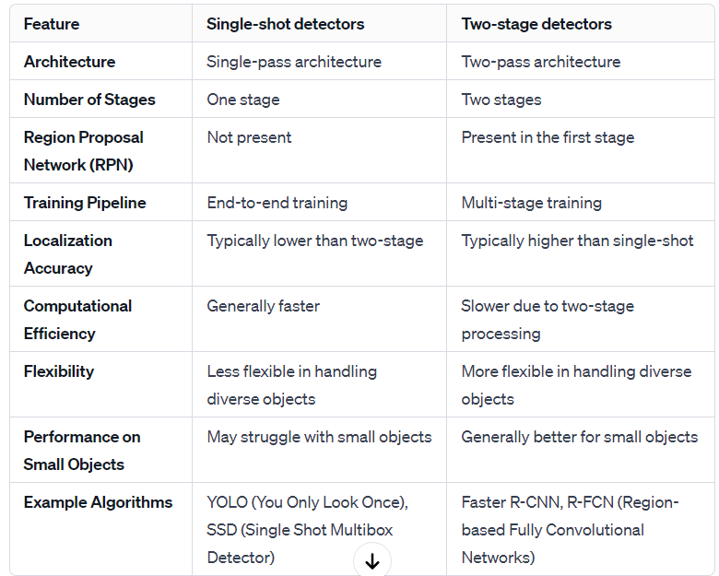

Object detection models performance evaluation metrics

- Intersection over union
Intersection over Union (IoU) measures object detection accuracy by comparing the overlap (intersection) to total area (union) of predicted and ground truth bounding boxes, quantified as IoU = Intersection / Union.
In object detection, precision and recall aren’t used for class predictions. Instead, they serve as predictions of boundary boxes for measuring the decision performance. An IoU value > 0.5. is taken as a positive prediction, while an IoU value < 0.5 is a negative prediction.

- Average Precision
Average Precision (AP) quantifies object detection performance by computing the area under the precision-recall curve. It reflects the model's accuracy across different classes, with mAP as the overall measure.

Average Precision (AP):
- Weighted mean of precisions at various thresholds.
- Weights based on the increase in recall from the prior threshold.
- Computed from precision-recall curve.
Mean Average Precision (mAP):
- Average of AP for each class.
- Accounts for precision-recall trade-off.
- Considers false positives and false negatives.
- Commonly used in object detection evaluations, especially in challenges like COCO.

Calculation Steps:
- Generate prediction scores.
- Convert scores to class labels.
- Compute confusion matrix (TP, FP, TN, FN).
- Calculate precision and recall.
- Determine area under the precision-recall curve.
- Measure average precision.
- mAP is the average of AP across classes.

Precision-Recall Curve Breakdown:
- Definition: A curve plotting precision and recall against model confidence score thresholds.
- Precision: Measures the accuracy of positive predictions. It asks, "When the model predicts positive, how often is it correct?"
- Recall: Measures the completeness of positive predictions. It asks, "Has the model predicted all positive instances it should have?"

Importance of Precision-Recall Curve:
Trade-off Analysis: Evaluates model performance across different confidence score thresholds.
Holistic View: Combines precision and recall, providing a comprehensive understanding of model behavior.

Why Precision and Recall Together:
Trade-off Illustration: Precision and recall can have an inverse relationship. A model with high recall might have low precision and vice versa.
Contextual Understanding: Helps identify the balance between minimizing false positives and false negatives.

Example Scenarios:
- High Recall, Low Precision: Many true positives but also many false positives.
- High Precision, Low Recall: Accurate positive predictions, but some positives are missed.

YOLO MODEL:
YOLO (You Only Look Once) revolutionized object detection by introducing an end-to-end neural network predicting bounding boxes and class probabilities simultaneously in a single pass. Unlike traditional methods, it achieves state-of-the-art results without multiple iterations, optimizing real-time detection efficiency and outperforming other algorithms in speed and accuracy.

Architecture of YOLO Model:
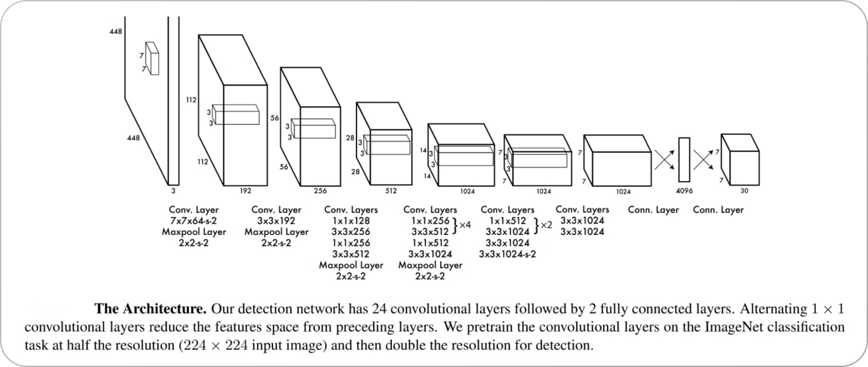

Pre-training and Conversion:
- Initial 20 convolution layers pre-trained with ImageNet.
- Adaptation for detection by adding layers.

Grid-based Detection:
- Image divided into S × S grid.
- Grid cells predict B bounding boxes and confidence scores.
Specialized Predictions:
- Training assigns responsibility based on highest IOU.
- Predictors specialize for improved recall.
Non-Maximum Suppression (NMS):
- Post-processing step for accurate and efficient object detection.
- Removes redundant or incorrect bounding boxes.

STEP INVOLVED IN VIDEO PROCESSING USING YOLO V8 MODEL WITH ROBOLFLOW PLATFORM AS FOLLOWS:

Step 1: Creating project
Before you start, you need to create a Roboflow account. Once you do that, you can create a new project in the Roboflow dashboard. Keep in mind to choose the right project type. In our case, Object Detection.
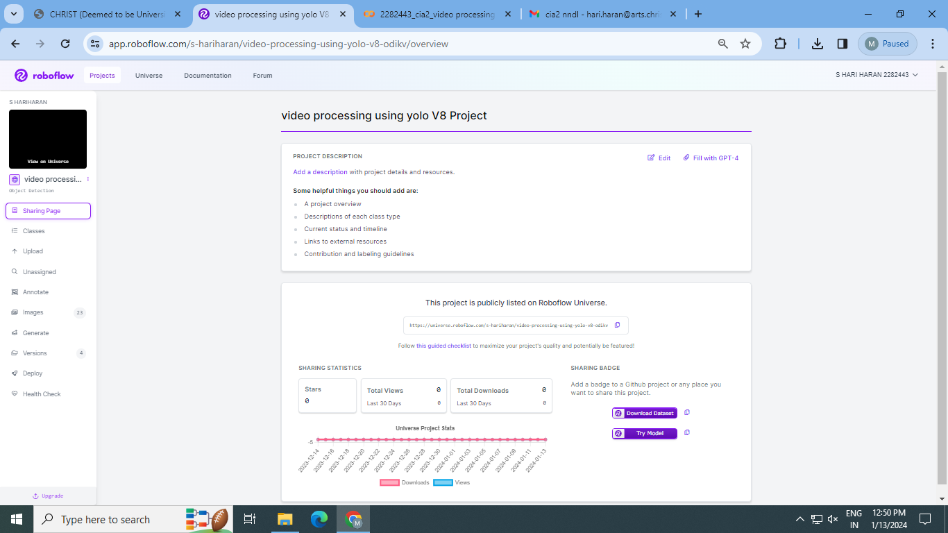

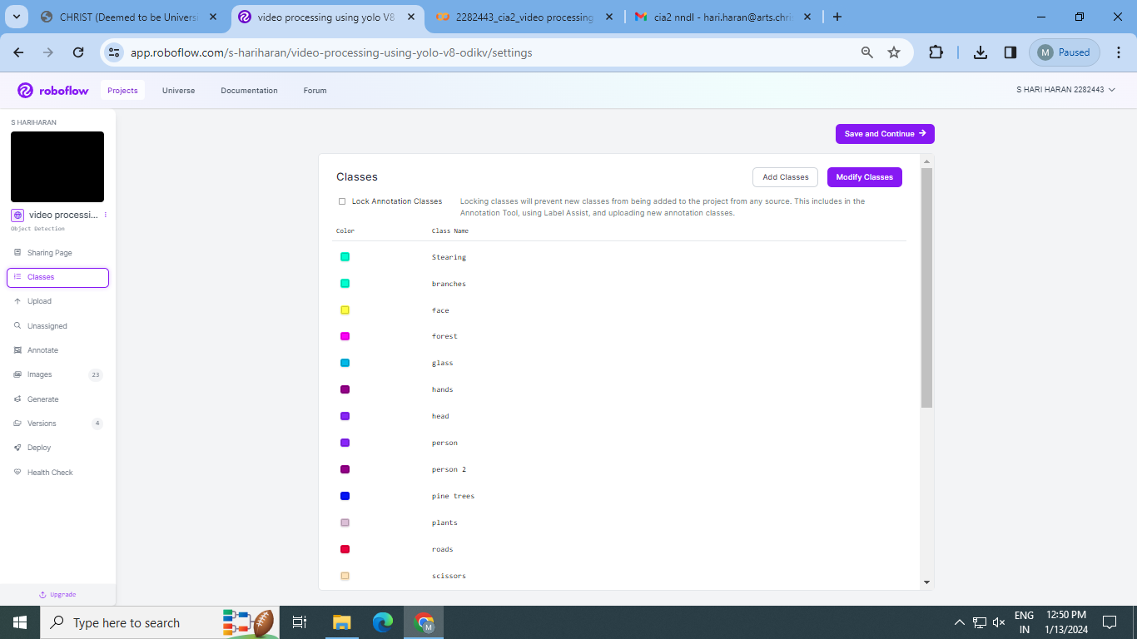

Step 2: Uploading images
Next, add the data to your newly created project. You can do it via API or through our web interface.
If you drag and drop a directory with a dataset in a supported format, the Roboflow dashboard will automatically read the images and annotations together.

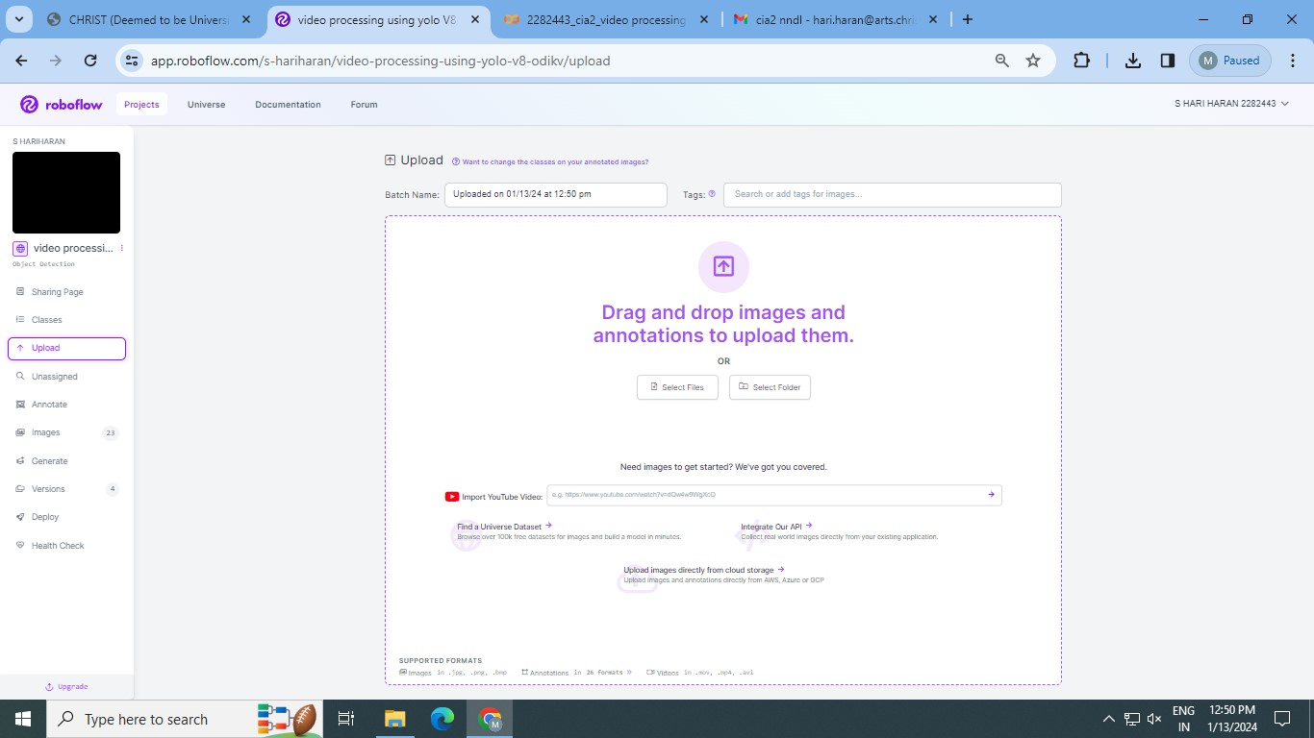

Step 3: Labeling and Dataset generation
If you only have images, you can label them in Roboflow Annotate.
Annotation Methods
You can annotate images by:
- Drawing bounding boxes and polygons manually
- Using Label Assist, a tool that uses model checkpoints (i.e. a previous version of your model) to recommend annotations
- Using Smart Polygon, a feature that creates polygon annotations with a few clicks.
- Using Label Assist with SAM, which uses the Segment Anything Model to create more precise polygon annotations with a few clicks.
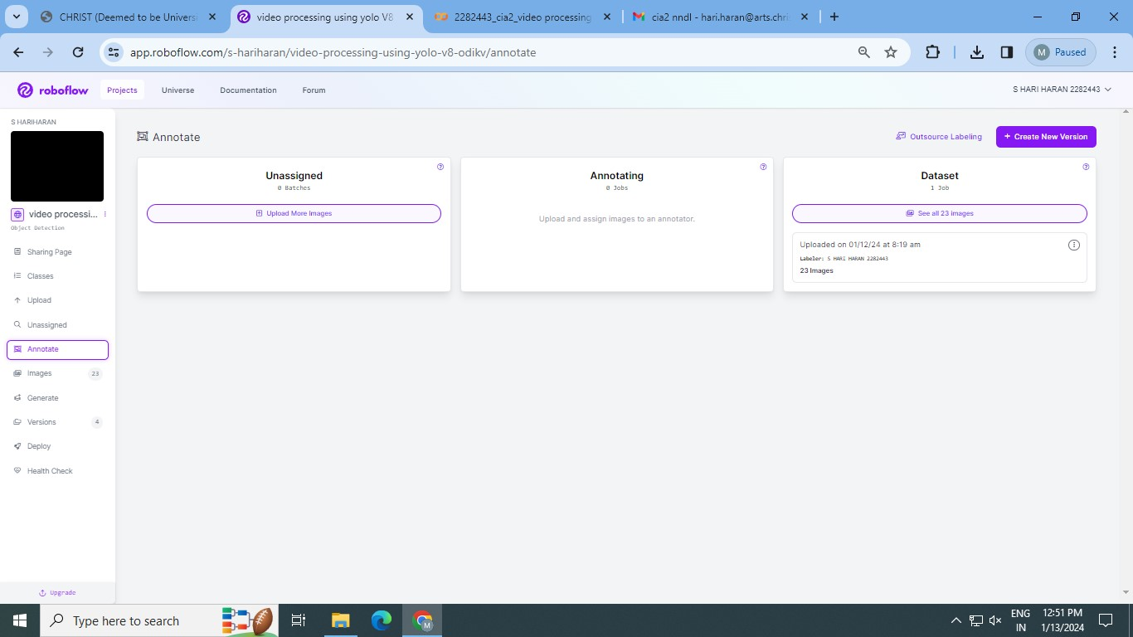

Step 4: Generate new dataset version
Now that we have our images and annotations added, we can Generate a Dataset Version. When Generating a Version, you may elect to add preprocessing and augmentations. This step is completely optional, however, it can allow you to significantly improve the robustness of your model.

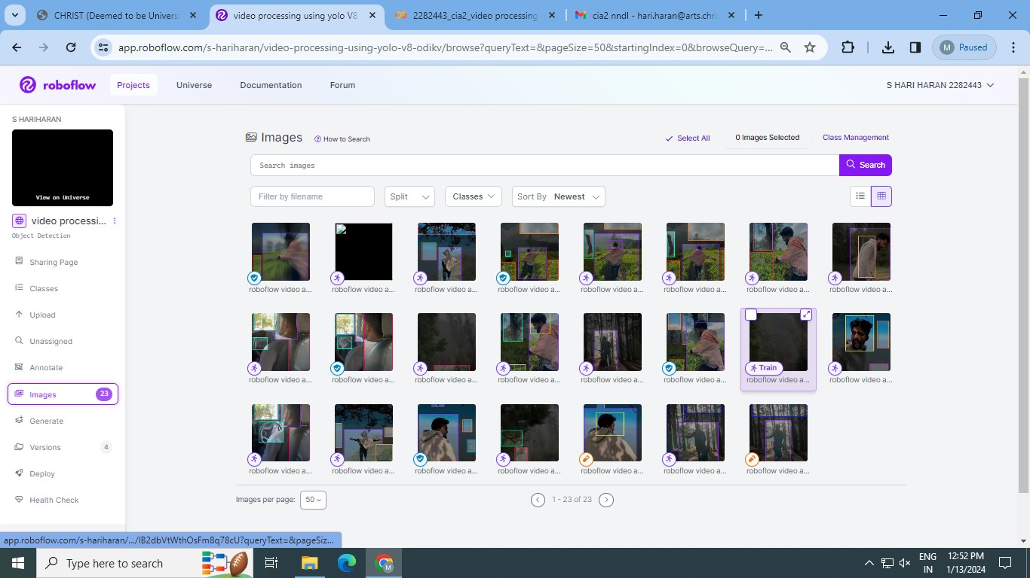

Step 5: Exporting dataset
Once the dataset version is generated, we have a hosted dataset we can load directly into our notebook for easy training. Click Export and select the YOLO v5 PyTorch dataset format.
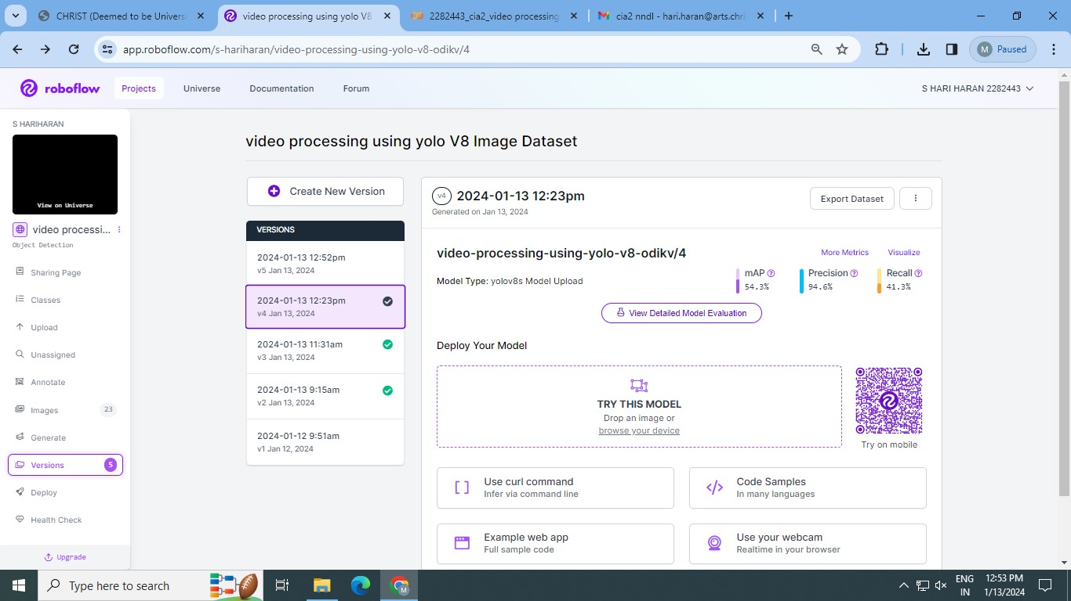

STEP 6: DEPLOYMENT OF THE MODEL
Once the model been trained in colab using yolo v8, upload the video and check whether the model is accurately running and detecting the objects as per the model trained.
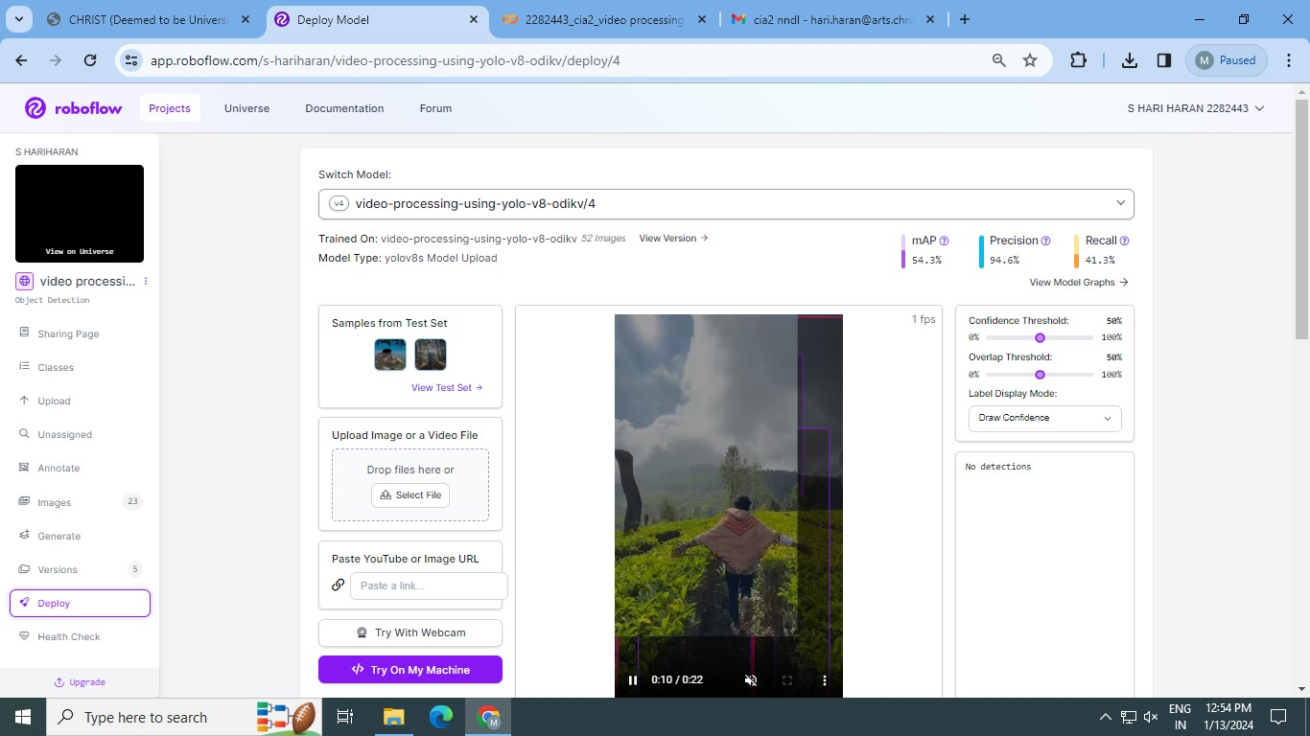
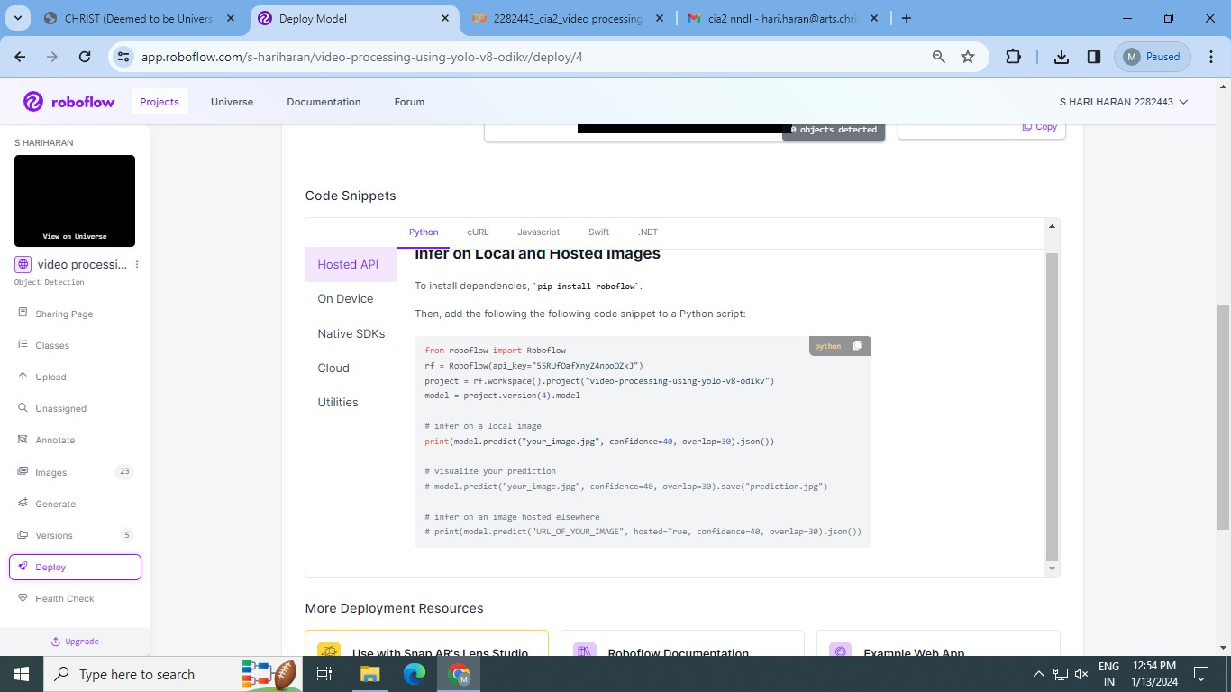

STEP 7: CHECKING THE SUMMARY STATISTICS OF THE MODEL
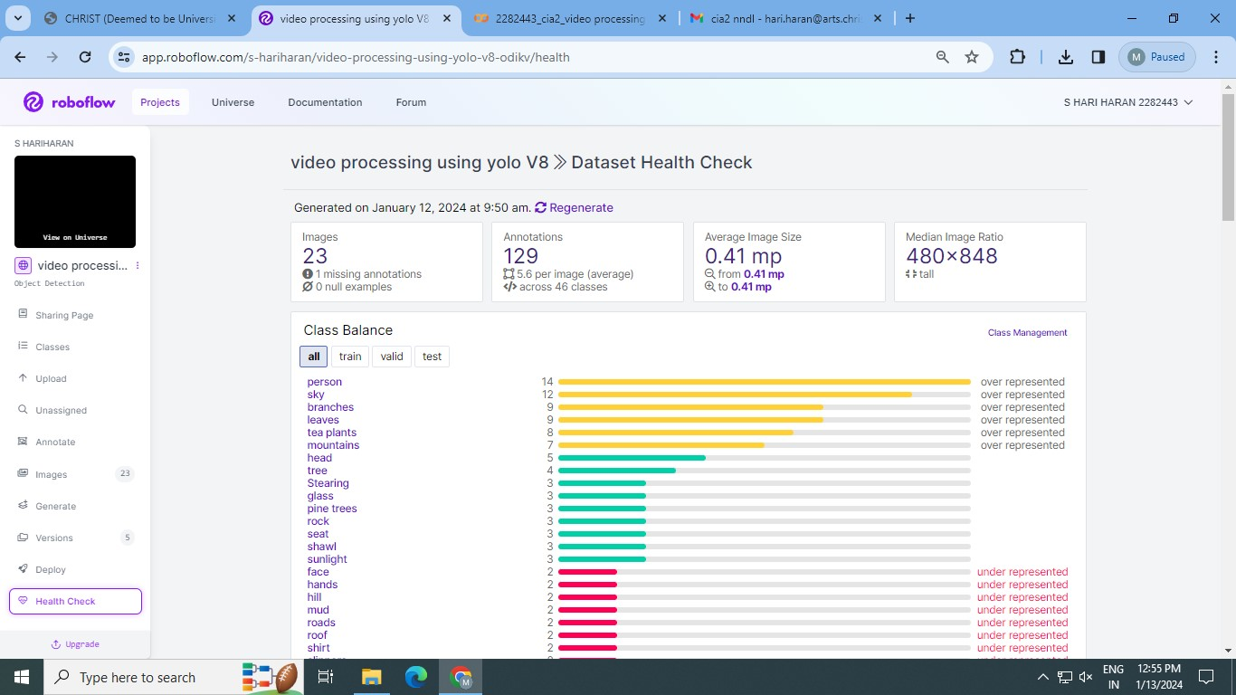

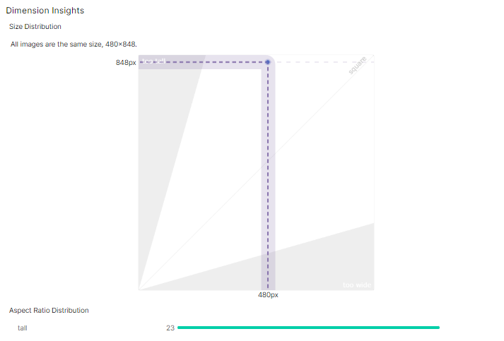
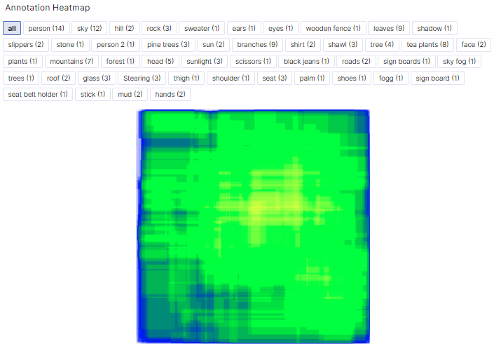
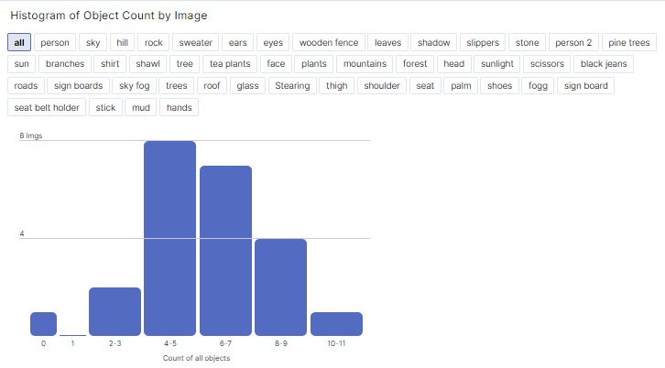

PYTHON CODES:
INTRODUCTION
Ultralytics YOLOv8 is the latest version of the YOLO (You Only Look Once) object detection and image segmentation model developed by Ultralytics. The YOLOv8 model is designed to be fast, accurate, and easy to use, making it an excellent choice for a wide range of object detection and image segmentation tasks. It can be trained on large datasets and is capable of running on a variety of hardware platforms, from CPUs to GPUs.

Pro Tip: Use GPU Acceleration
If you are running this notebook in Google Colab, navigate to Edit -> Notebook settings -> Hardware accelerator, set it to GPU, and then click Save. This will ensure your notebook uses a GPU, which will significantly speed up model training times.

Steps in this Tutorial
In this tutorial, we are going to cover:
- Before you start
- Install YOLOv8
- CLI Basics
- Inference with Pre-trained COCO Model
- Roboflow Universe
- Preparing a custom dataset
- Custom Training
- Validate Custom Model
- Inference with Custom Model

Before you start
Let's make sure that we have access to GPU. We can use nvidia-smi command to do that. In case of any problems navigate to Edit -> Notebook settings -> Hardware accelerator, set it to GPU, and then click Save.
!nvidia-smi
Sat Jan 13 07:05:56 2024
+---------------------------------------------------------------------------------------+
| NVIDIA-SMI 535.104.05 Driver Version: 535.104.05 CUDA Version: 12.2 |
|-----------------------------------------+----------------------+----------------------+
| GPU Name Persistence-M | Bus-Id Disp.A | Volatile Uncorr. ECC |
| Fan Temp Perf Pwr:Usage/Cap | Memory-Usage | GPU-Util Compute M. |
| | | MIG M. |
|=========================================+======================+======================|
| 0 Tesla T4 Off | 00000000:00:04.0 Off | 0 |
| N/A 66C P0 31W / 70W | 419MiB / 15360MiB | 0% Default |
| | | N/A |
+-----------------------------------------+----------------------+----------------------+
+---------------------------------------------------------------------------------------+
| Processes: |
| GPU GI CI PID Type Process name GPU Memory |
| ID ID Usage |
|=======================================================================================|
+---------------------------------------------------------------------------------------+
import os
HOME = os.getcwd()
print(HOME)
/content/datasets

Install YOLOv8
⚠️ YOLOv8 is still under heavy development. Breaking changes are being introduced almost weekly. We strive to make our YOLOv8 notebooks work with the latest version of the library. Last tests took place on 03.01.2024 with version YOLOv8.0.196.
If you notice that our notebook behaves incorrectly - especially if you experience errors that prevent you from going through the tutorial - don't hesitate! Let us know and open an issue on the Roboflow Notebooks repository.
YOLOv8 can be installed in two ways - from the source and via pip. This is because it is the first iteration of YOLO to have an official package.
# Pip install method (recommended)
!pip install ultralytics==8.0.196
from IPython import display
display.clear_output()
import ultralytics
ultralytics.checks()
Ultralytics YOLOv8.0.196 🚀 Python-3.10.12 torch-2.1.0+cu121 CUDA:0 (Tesla T4, 15102MiB)
Setup complete ✅ (2 CPUs, 12.7 GB RAM, 26.7/78.2 GB disk)
# Git clone method (for development)
# %cd {HOME}
# !git clone github.com/ultralytics/ultralytics
# %cd {HOME}/ultralytics
# !pip install -e .
# from IPython import display
# display.clear_output()
# import ultralytics
# ultralytics.checks()
from ultralytics import YOLO
from IPython.display import display, Image

CLI Basics
If you want to train, validate or run inference on models and don't need to make any modifications to the code, using YOLO command line interface is the easiest way to get started. Read more about CLI in Ultralytics YOLO Docs.
yolo task=detect mode=train model=yolov8n.yaml args...
classify predict yolov8n-cls.yaml args...
segment val yolov8n-seg.yaml args...
export yolov8n.pt format=onnx args...

Inference with Pre-trained COCO Model

💻 CLI
yolo mode=predict runs YOLOv8 inference on a variety of sources, downloading models automatically from the latest YOLOv8 release, and saving results to runs/predict.
%cd {HOME}
!yolo task=detect mode=predict model=yolov8n.pt conf=0.25 source='https://media.roboflow.com/notebooks/examples/dog.jpeg' save=True
/content/datasets
Ultralytics YOLOv8.0.196 🚀 Python-3.10.12 torch-2.1.0+cu121 CUDA:0 (Tesla T4, 15102MiB)
YOLOv8n summary (fused): 168 layers, 3151904 parameters, 0 gradients, 8.7 GFLOPs
Found https://media.roboflow.com/notebooks/examples/dog.jpeg locally at dog.jpeg
WARNING ⚠️ NMS time limit 0.550s exceeded
image 1/1 /content/datasets/dog.jpeg: 640x384 1 person, 1 car, 1 dog, 113.9ms
Speed: 3.2ms preprocess, 113.9ms inference, 934.2ms postprocess per image at shape (1, 3, 640, 384)
Results saved to runs/detect/predict3
💡 Learn more at https://docs.ultralytics.com/modes/predict
(SAMPLE DEDICTION)
%cd {HOME}
Image(filename='runs/detect/predict/dog.jpeg', height=600)
/content/datasets
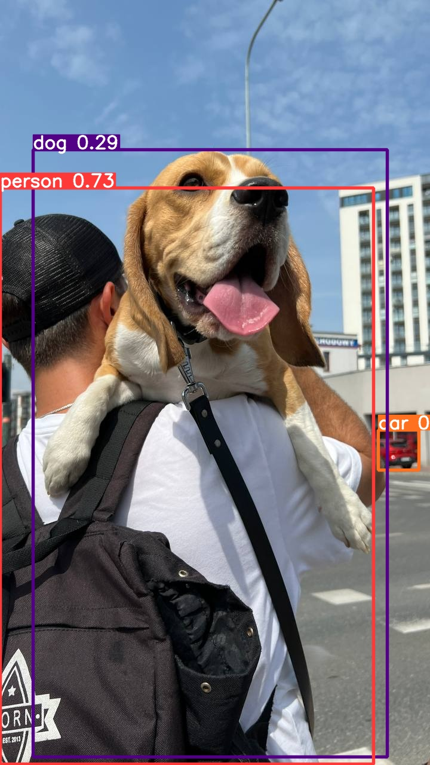

🐍 Python SDK
The simplest way of simply using YOLOv8 directly in a Python environment.
model = YOLO(f'{HOME}/yolov8n.pt')
results = model.predict(source='https://media.roboflow.com/notebooks/examples/dog.jpeg', conf=0.25)
Found https://media.roboflow.com/notebooks/examples/dog.jpeg locally at dog.jpeg
image 1/1 /content/datasets/dog.jpeg: 640x384 1 person, 1 car, 1 dog, 50.7ms
Speed: 2.0ms preprocess, 50.7ms inference, 1.8ms postprocess per image at shape (1, 3, 640, 384)
results[0].boxes.xyxy
tensor([[ 0.0000, 314.4717, 625.0754, 1278.1946],
[ 55.1731, 250.0220, 648.1080, 1266.2720],
[ 633.2291, 719.5391, 701.0538, 786.0336]], device='cuda:0')
results[0].boxes.conf
tensor([0.7271, 0.2907, 0.2846], device='cuda:0')
results[0].boxes.cls
tensor([ 0., 16., 2.], device='cuda:0')

Preparing a custom dataset
Building a custom dataset can be a painful process. It might take dozens or even hundreds of hours to collect images, label them, and export them in the proper format. Fortunately, Roboflow makes this process as straightforward and fast as possible. Let me show you how!
!mkdir {HOME}/datasets
%cd {HOME}/datasets
!pip install roboflow
from roboflow import Roboflow
rf = Roboflow(api_key="55RUfOafXnyZ4npoOZkJ")
project = rf.workspace("s-hariharan").project("video-processing-using-yolo-v8-odikv")
dataset = project.version(4).download("yolov8")
mkdir: cannot create directory ‘/content/datasets/datasets’: File exists
/content/datasets/datasets
Requirement already satisfied: roboflow in /usr/local/lib/python3.10/dist-packages (1.1.16)
Requirement already satisfied: certifi==2023.7.22 in /usr/local/lib/python3.10/dist-packages (from roboflow) (2023.7.22)
Requirement already satisfied: chardet==4.0.0 in
loading Roboflow project...
Downloading Dataset Version Zip in video-processing-using-yolo-V8-4 to yolov8:: 100%|██████████| 2064/2064 [00:00<00:00, 15792.05it/s]
Extracting Dataset Version Zip to video-processing-using-yolo-V8-4 in yolov8:: 100%|██████████| 116/116 [00:00<00:00, 3892.75it/s]

Custom Training
%cd {HOME}
!yolo task=detect mode=train model=yolov8s.pt data={dataset.location}/data.yaml epochs=25 imgsz=800 plots=True
/content/datasets
New https://pypi.org/project/ultralytics/8.1.1 available 😃 Update with 'pip install -U ultralytics'
Ultralytics YOLOv8.0.196 🚀 Python-3.10.12 torch-2.1.0+cu121 CUDA:0 (Tesla T4, 15102MiB)
Overriding model.yaml nc=80 with nc=17
from n params module arguments
0 -1 1 928 ultralytics.nn.modules.conv.Conv [3, 32, 3, 2]
1 -1 1 18560 ultralytics.nn.modules.conv.Conv [32, 64, 3, 2]
2 -1 1 29056 ultralytics.nn.modules.block.C2f [64, 64, 1, True]
3 -1 1 73984 ultralytics.nn.modules.conv.Conv [64, 128, 3, 2]
4 -1 2 197632 ultralytics.nn.modules.block.C2f [128, 128, 2, True]
5 -1 1 295424 ultralytics.nn.modules.conv.Conv [128, 256, 3, 2]
6 -1 2 788480 ultralytics.nn.modules.block.C2f [256, 256, 2, True]
7 -1 1 1180672 ultralytics.nn.modules.conv.Conv [256, 512, 3, 2]
8 -1 1 1838080 ultralytics.nn.modules.block.C2f [512, 512, 1, True]
9 -1 1 656896 ultralytics.nn.modules.block.SPPF [512, 512, 5]
10 -1 1 0 torch.nn.modules.upsampling.Upsample [None, 2, 'nearest']
11 [-1, 6] 1 0 ultralytics.nn.modules.conv.Concat [1]
12 -1 1 591360 ultralytics.nn.modules.block.C2f [768, 256, 1]
13 -1 1 0 torch.nn.modules.upsampling.Upsample [None, 2, 'nearest']
14 [-1, 4] 1 0 ultralytics.nn.modules.conv.Concat [1]
15 -1 1 148224 ultralytics.nn.modules.block.C2f [384, 128, 1]
16 -1 1 147712 ultralytics.nn.modules.conv.Conv [128, 128, 3, 2]
17 [-1, 12] 1 0 ultralytics.nn.modules.conv.Concat [1]
18 -1 1 493056 ultralytics.nn.modules.block.C2f [384, 256, 1]
19 -1 1 590336 ultralytics.nn.modules.conv.Conv [256, 256, 3, 2]
20 [-1, 9] 1 0 ultralytics.nn.modules.conv.Concat [1]
21 -1 1 1969152 ultralytics.nn.modules.block.C2f [768, 512, 1]
22 [15, 18, 21] 1 2122627 ultralytics.nn.modules.head.Detect [17, [128, 256, 512]]
Model summary: 225 layers, 11142179 parameters, 11142163 gradients, 28.7 GFLOPs
Transferred 349/355 items from pretrained weights
TensorBoard: Start with 'tensorboard --logdir runs/detect/train2', view at http://localhost:6006/
Freezing layer 'model.22.dfl.conv.weight'
AMP: running Automatic Mixed Precision (AMP) checks with YOLOv8n...
WARNING ⚠️ NMS time limit 0.550s exceeded
AMP: checks passed ✅
train: Scanning /content/datasets/datasets/video-processing-using-yolo-V8-4/train/labels.cache... 45 images, 3 backgrounds, 0 corrupt: 100% 45/45 [00:00<?, ?it/s]
albumentations: Blur(p=0.01, blur_limit=(3, 7)), MedianBlur(p=0.01, blur_limit=(3, 7)), ToGray(p=0.01), CLAHE(p=0.01, clip_limit=(1, 4.0), tile_grid_size=(8, 8))
val: Scanning /content/datasets/datasets/video-processing-using-yolo-V8-4/valid/labels.cache... 5 images, 0 backgrounds, 0 corrupt: 100% 5/5 [00:00<?, ?it/s]
Plotting labels to runs/detect/train2/labels.jpg...
optimizer: 'optimizer=auto' found, ignoring 'lr0=0.01' and 'momentum=0.937' and determining best 'optimizer', 'lr0' and 'momentum' automatically...
optimizer: AdamW(lr=0.000476, momentum=0.9) with parameter groups 57 weight(decay=0.0), 64 weight(decay=0.0005), 63 bias(decay=0.0)
Image sizes 800 train, 800 val
Using 2 dataloader workers
Logging results to runs/detect/train2
Starting training for 25 epochs...
Epoch GPU_mem box_loss cls_loss dfl_loss Instances Size
1/25 6.21G 2.345 8.224 2.649 54 800: 100% 3/3 [00:03<00:00, 1.27s/it]
Class Images Instances Box(P R mAP50 mAP50-95): 100% 1/1 [00:00<00:00, 1.07it/s]
all 5 17 0.123 0.0556 0.0121 0.00414
Epoch GPU_mem box_loss cls_loss dfl_loss Instances Size
2/25 6.42G 2.393 8.145 2.587 69 800: 100% 3/3 [00:01<00:00, 2.14it/s]
Class Images Instances Box(P R mAP50 mAP50-95): 100% 1/1 [00:00<00:00, 2.85it/s]
all 5 17 0.12 0.0556 0.0113 0.0049
Epoch GPU_mem box_loss cls_loss dfl_loss Instances Size
3/25 6.17G 2.351 7.857 2.543 59 800: 100% 3/3 [00:01<00:00, 2.21it/s]
Class Images Instances Box(P R mAP50 mAP50-95): 100% 1/1 [00:00<00:00, 8.86it/s]
all 5 17 0.127 0.0833 0.0129 0.00561
Epoch GPU_mem box_loss cls_loss dfl_loss Instances Size
4/25 6.46G 2.325 6.591 2.53 71 800: 100% 3/3 [00:01<00:00, 2.22it/s]
Class Images Instances Box(P R mAP50 mAP50-95): 100% 1/1 [00:00<00:00, 1.84it/s]
all 5 17 0.372 0.0556 0.0311 0.0111
Epoch GPU_mem box_loss cls_loss dfl_loss Instances Size
5/25 6.53G 2.165 4.716 2.353 81 800: 100% 3/3 [00:01<00:00, 2.50it/s]
Class Images Instances Box(P R mAP50 mAP50-95): 100% 1/1 [00:00<00:00, 1.55it/s]
all 5 17 0.625 0.0556 0.0523 0.0209
Epoch GPU_mem box_loss cls_loss dfl_loss Instances Size
6/25 6.52G 2.135 4.469 2.295 75 800: 100% 3/3 [00:01<00:00, 2.40it/s]
Class Images Instances Box(P R mAP50 mAP50-95): 0% 0/1 [00:00<?, ?it/s]WARNING ⚠️ NMS time limit 0.750s exceeded
Class Images Instances Box(P R mAP50 mAP50-95): 100% 1/1 [00:00<00:00, 1.06it/s]
all 5 17 0.661 0.0556 0.0806 0.0312
Epoch GPU_mem box_loss cls_loss dfl_loss Instances Size
7/25 6.53G 1.93 4.088 2.179 93 800: 100% 3/3 [00:01<00:00, 2.61it/s]
Class Images Instances Box(P R mAP50 mAP50-95): 100% 1/1 [00:00<00:00, 1.55it/s]
all 5 17 0.401 0.157 0.226 0.0966
Epoch GPU_mem box_loss cls_loss dfl_loss Instances Size
8/25 6.53G 1.863 3.78 2.134 63 800: 100% 3/3 [00:01<00:00, 2.61it/s]
Class Images Instances Box(P R mAP50 mAP50-95): 100% 1/1 [00:00<00:00, 1.54it/s]
all 5 17 0.366 0.269 0.286 0.0942
Epoch GPU_mem box_loss cls_loss dfl_loss Instances Size
9/25 6.54G 1.801 3.664 2.108 59 800: 100% 3/3 [00:01<00:00, 2.59it/s]
Class Images Instances Box(P R mAP50 mAP50-95): 100% 1/1 [00:00<00:00, 1.49it/s]
all 5 17 0.649 0.269 0.368 0.135
Epoch GPU_mem box_loss cls_loss dfl_loss Instances Size
10/25 6.51G 1.889 3.53 2.12 69 800: 100% 3/3 [00:01<00:00, 2.32it/s]
Class Images Instances Box(P R mAP50 mAP50-95): 0% 0/1 [00:00<?, ?it/s]WARNING ⚠️ NMS time limit 0.750s exceeded
Class Images Instances Box(P R mAP50 mAP50-95): 100% 1/1 [00:00<00:00, 1.10it/s]
all 5 17 0.397 0.38 0.313 0.136
Epoch GPU_mem box_loss cls_loss dfl_loss Instances Size
11/25 6.55G 1.816 3.52 2.136 52 800: 100% 3/3 [00:01<00:00, 2.62it/s]
Class Images Instances Box(P R mAP50 mAP50-95): 100% 1/1 [00:00<00:00, 2.02it/s]
all 5 17 0.598 0.37 0.364 0.168
Epoch GPU_mem box_loss cls_loss dfl_loss Instances Size
12/25 6.48G 1.766 3.217 2.03 78 800: 100% 3/3 [00:01<00:00, 2.68it/s]
Class Images Instances Box(P R mAP50 mAP50-95): 100% 1/1 [00:00<00:00, 2.16it/s]
all 5 17 0.668 0.38 0.359 0.193
Epoch GPU_mem box_loss cls_loss dfl_loss Instances Size
13/25 6.51G 1.719 3.216 1.984 80 800: 100% 3/3 [00:01<00:00, 2.61it/s]
Class Images Instances Box(P R mAP50 mAP50-95): 100% 1/1 [00:00<00:00, 2.93it/s]
all 5 17 0.781 0.343 0.366 0.185
Epoch GPU_mem box_loss cls_loss dfl_loss Instances Size
14/25 6.5G 1.661 2.86 1.919 81 800: 100% 3/3 [00:01<00:00, 2.43it/s]
Class Images Instances Box(P R mAP50 mAP50-95): 100% 1/1 [00:00<00:00, 2.82it/s]
all 5 17 0.76 0.37 0.447 0.232
Epoch GPU_mem box_loss cls_loss dfl_loss Instances Size
15/25 6.53G 1.734 3.016 1.975 50 800: 100% 3/3 [00:01<00:00, 2.02it/s]
Class Images Instances Box(P R mAP50 mAP50-95): 100% 1/1 [00:00<00:00, 5.19it/s]
all 5 17 0.492 0.444 0.47 0.223
Closing dataloader mosaic
albumentations: Blur(p=0.01, blur_limit=(3, 7)), MedianBlur(p=0.01, blur_limit=(3, 7)), ToGray(p=0.01), CLAHE(p=0.01, clip_limit=(1, 4.0), tile_grid_size=(8, 8))
Epoch GPU_mem box_loss cls_loss dfl_loss Instances Size
16/25 6.49G 1.827 3.836 2.146 36 800: 100% 3/3 [00:02<00:00, 1.44it/s]
Class Images Instances Box(P R mAP50 mAP50-95): 100% 1/1 [00:00<00:00, 1.58it/s]
all 5 17 0.772 0.417 0.48 0.262
Epoch GPU_mem box_loss cls_loss dfl_loss Instances Size
17/25 6.51G 1.699 3.4 2.084 31 800: 100% 3/3 [00:01<00:00, 2.44it/s]
Class Images Instances Box(P R mAP50 mAP50-95): 100% 1/1 [00:00<00:00, 4.71it/s]
all 5 17 0.845 0.386 0.481 0.264
Epoch GPU_mem box_loss cls_loss dfl_loss Instances Size
18/25 6.51G 1.613 3.245 2.005 40 800: 100% 3/3 [00:01<00:00, 2.63it/s]
Class Images Instances Box(P R mAP50 mAP50-95): 100% 1/1 [00:00<00:00, 5.56it/s]
all 5 17 0.857 0.373 0.47 0.271
Epoch GPU_mem box_loss cls_loss dfl_loss Instances Size
19/25 6.51G 1.551 3.153 2.044 32 800: 100% 3/3 [00:01<00:00, 2.69it/s]
Class Images Instances Box(P R mAP50 mAP50-95): 100% 1/1 [00:00<00:00, 5.03it/s]
all 5 17 0.932 0.385 0.47 0.283
Epoch GPU_mem box_loss cls_loss dfl_loss Instances Size
20/25 6.51G 1.709 3.19 2.111 34 800: 100% 3/3 [00:01<00:00, 2.68it/s]
Class Images Instances Box(P R mAP50 mAP50-95): 100% 1/1 [00:00<00:00, 5.89it/s]
all 5 17 0.923 0.417 0.473 0.295
Epoch GPU_mem box_loss cls_loss dfl_loss Instances Size
21/25 6.51G 1.534 3.014 1.905 34 800: 100% 3/3 [00:01<00:00, 2.20it/s]
Class Images Instances Box(P R mAP50 mAP50-95): 100% 1/1 [00:00<00:00, 3.55it/s]
all 5 17 0.908 0.417 0.485 0.3
Epoch GPU_mem box_loss cls_loss dfl_loss Instances Size
22/25 6.51G 1.524 2.943 1.989 38 800: 100% 3/3 [00:01<00:00, 2.56it/s]
Class Images Instances Box(P R mAP50 mAP50-95): 100% 1/1 [00:00<00:00, 7.18it/s]
all 5 17 0.914 0.417 0.484 0.308
Epoch GPU_mem box_loss cls_loss dfl_loss Instances Size
23/25 6.49G 1.5 2.856 1.914 41 800: 100% 3/3 [00:01<00:00, 2.63it/s]
Class Images Instances Box(P R mAP50 mAP50-95): 100% 1/1 [00:00<00:00, 9.64it/s]
all 5 17 0.922 0.405 0.535 0.315
Epoch GPU_mem box_loss cls_loss dfl_loss Instances Size
24/25 6.51G 1.461 2.814 1.864 30 800: 100% 3/3 [00:01<00:00, 2.61it/s]
Class Images Instances Box(P R mAP50 mAP50-95): 100% 1/1 [00:00<00:00, 7.64it/s]
all 5 17 0.951 0.412 0.527 0.329
Epoch GPU_mem box_loss cls_loss dfl_loss Instances Size
25/25 6.51G 1.398 2.773 1.874 40 800: 100% 3/3 [00:01<00:00, 2.60it/s]
Class Images Instances Box(P R mAP50 mAP50-95): 100% 1/1 [00:00<00:00, 7.05it/s]
all 5 17 0.946 0.413 0.543 0.332
25 epochs completed in 0.027 hours.
Optimizer stripped from runs/detect/train2/weights/last.pt, 22.6MB
Optimizer stripped from runs/detect/train2/weights/best.pt, 22.6MB
Validating runs/detect/train2/weights/best.pt...
Ultralytics YOLOv8.0.196 🚀 Python-3.10.12 torch-2.1.0+cu121 CUDA:0 (Tesla T4, 15102MiB)
Model summary (fused): 168 layers, 11132163 parameters, 0 gradients, 28.5 GFLOPs
Class Images Instances Box(P R mAP50 mAP50-95): 100% 1/1 [00:00<00:00, 9.33it/s]
all 5 17 0.945 0.414 0.543 0.332
Stearing 5 1 1 0 0 0
branches 5 1 1 0 0 0
glass 5 1 0.878 1 0.995 0.697
head 5 1 0.829 1 0.995 0.796
person 5 4 1 0.727 0.778 0.457
seat 5 1 0.8 1 0.995 0.547
sky 5 3 1 0 0.333 0.164
tea plants 5 4 1 0 0.688 0.308
tree 5 1 1 0 0.0995 0.0199
Speed: 0.3ms preprocess, 10.0ms inference, 0.0ms loss, 5.3ms postprocess per image
Results saved to runs/detect/train2
💡 Learn more at https://docs.ultralytics.com/modes/train
!ls {HOME}/runs/detect/train/
args.yaml P_curve.png train_batch1.jpg
confusion_matrix_normalized.png PR_curve.png train_batch2.jpg
confusion_matrix.png R_curve.png train_batch45.jpg
events.out.tfevents.1705129131.613d2623ed74.1314.0 results.csv train_batch46.jpg
F1_curve.png results.png train_batch47.jpg
labels_correlogram.jpg roboflow_deploy.zip val_batch0_labels.jpg
labels.jpg state_dict.pt val_batch0_pred.jpg
model_artifacts.json train_batch0.jpg weights

%cd {HOME}
Image(filename=f'{HOME}/runs/detect/train/confusion_matrix.png', width=600)
/content/datasets
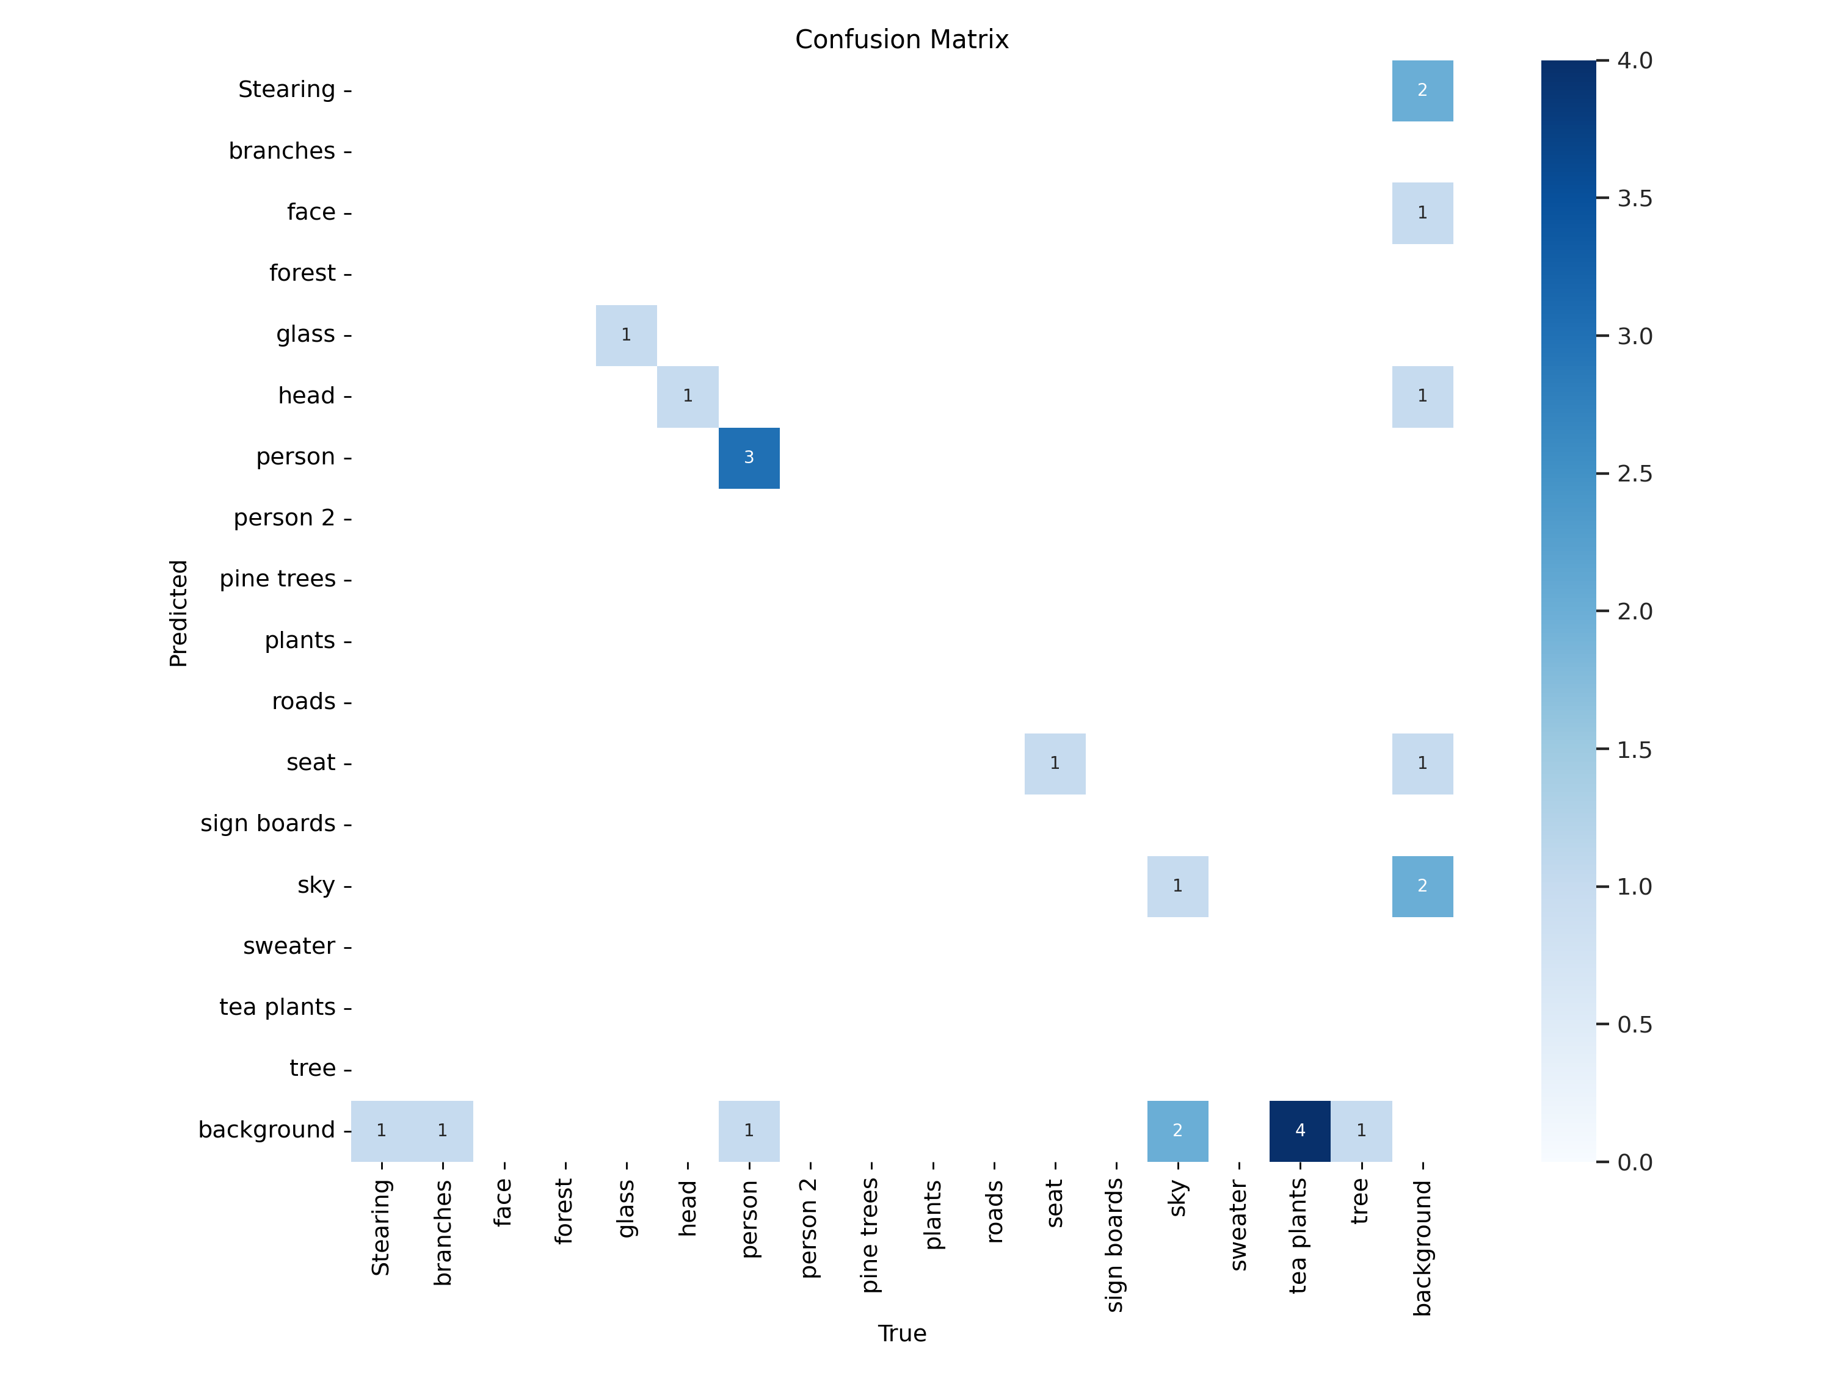
%cd {HOME}
Image(filename=f'{HOME}/runs/detect/train/results.png', width=600)
/content/datasets
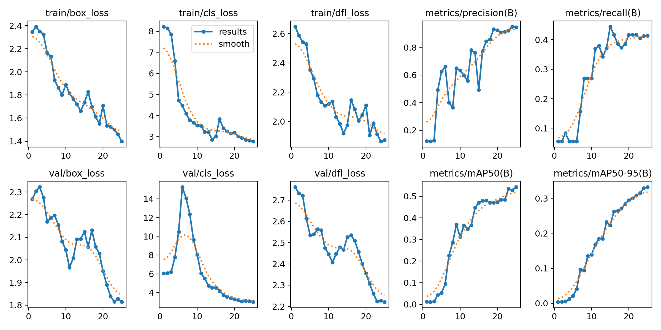

%cd {HOME}
Image(filename=f'{HOME}/runs/detect/train/val_batch0_pred.jpg', width=600)
/content/datasets
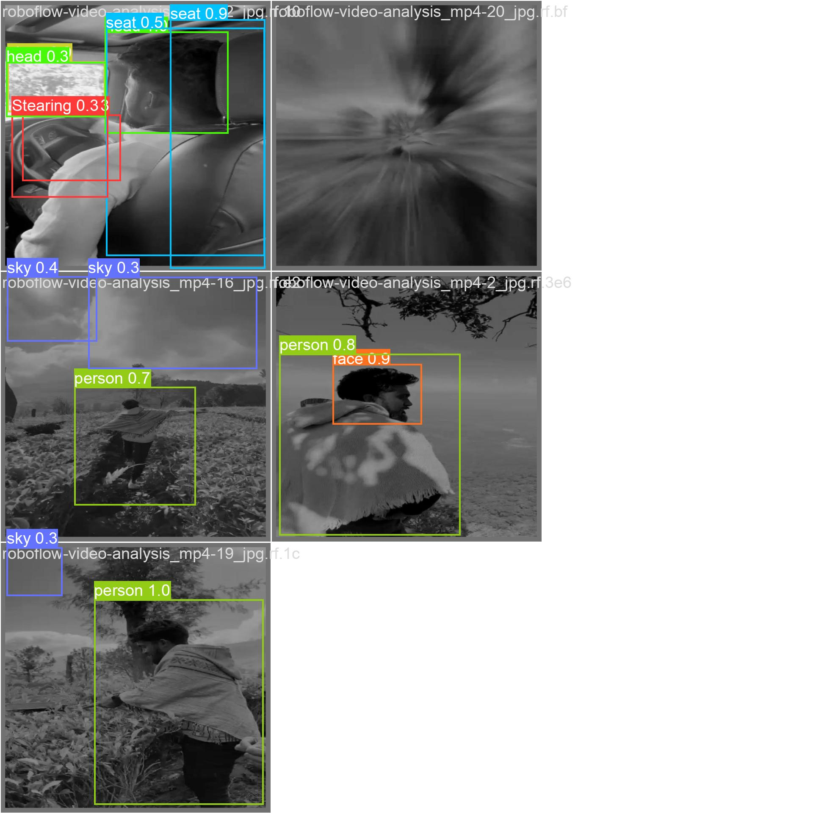

Validate Custom Model
%cd {HOME}
!yolo task=detect mode=val model={HOME}/runs/detect/train/weights/best.pt data={dataset.location}/data.yaml
/content/datasets
Ultralytics YOLOv8.0.196 🚀 Python-3.10.12 torch-2.1.0+cu121 CUDA:0 (Tesla T4, 15102MiB)
Model summary (fused): 168 layers, 11132163 parameters, 0 gradients, 28.5 GFLOPs
val: Scanning /content/datasets/datasets/video-processing-using-yolo-V8-4/valid/labels.cache... 5 images, 0 backgrounds, 0 corrupt: 100% 5/5 [00:00<?, ?it/s]
Class Images Instances Box(P R mAP50 mAP50-95): 100% 1/1 [00:00<00:00, 1.30it/s]
all 5 17 0.946 0.412 0.543 0.332
Stearing 5 1 1 0 0 0
branches 5 1 1 0 0 0
glass 5 1 0.867 1 0.995 0.697
head 5 1 0.834 1 0.995 0.796
person 5 4 1 0.706 0.777 0.457
seat 5 1 0.808 1 0.995 0.547
sky 5 3 1 0 0.333 0.164
tea plants 5 4 1 0 0.688 0.309
tree 5 1 1 0 0.0995 0.0199
Speed: 0.4ms preprocess, 23.9ms inference, 0.0ms loss, 110.5ms postprocess per image
Results saved to runs/detect/val2
💡 Learn more at https://docs.ultralytics.com/modes/val

Inference with Custom Model
%cd {HOME}
!yolo task=detect mode=predict model={HOME}/runs/detect/train/weights/best.pt conf=0.25 source={dataset.location}/test/images save=True
/content/datasets
Ultralytics YOLOv8.0.196 🚀 Python-3.10.12 torch-2.1.0+cu121 CUDA:0 (Tesla T4, 15102MiB)
Model summary (fused): 168 layers, 11132163 parameters, 0 gradients, 28.5 GFLOPs
WARNING ⚠️ NMS time limit 0.550s exceeded
image 1/2 /content/datasets/datasets/video-processing-using-yolo-V8-4/test/images/roboflow-video-analysis_mp4-1_jpg.rf.d269b698601f462b6e9f8a7d004b17b9.jpg: 800x800 1 face, 26.1ms
image 2/2 /content/datasets/datasets/video-processing-using-yolo-V8-4/test/images/roboflow-video-analysis_mp4-5_jpg.rf.9101cac02fd3b3dd192dd5bdf852d7a6.jpg: 800x800 1 person, 22.6ms
Speed: 10.4ms preprocess, 24.3ms inference, 452.7ms postprocess per image at shape (1, 3, 800, 800)
Results saved to runs/detect/predict4
💡 Learn more at https://docs.ultralytics.com/modes/predict
NOTE: Let's take a look at few results.
import glob
from IPython.display import Image, display
for image_path in glob.glob(f'{HOME}/runs/detect/predict3/*.jpg')[:3]:
display(Image(filename=image_path, width=600))
print("\n")

Deploy model on Roboflow
Once you have finished training your YOLOv8 model, you’ll have a set of trained weights ready for use. These weights will be in the /runs/detect/train/weights/best.pt folder of your project. You can upload your model weights to Roboflow Deploy to use your trained weights on our infinitely scalable infrastructure.
The .deploy() function in the Roboflow pip package now supports uploading YOLOv8 weights.
To upload model weights, add the following code to the “Inference with Custom Model” section in the aforementioned notebook:
project.version(dataset.version).deploy(model_type="yolov8", model_path=f"{HOME}/runs/detect/train/")
An error occured when getting the model upload URL: This version already has a trained model. Please generate and train a new version in order to upload model to Roboflow.
#While your deployment is processing, checkout the deployment docs to take your model to most destinations https://docs.roboflow.com/inference
#Run inference on your model on a persistant, auto-scaling, cloud API
#load model
model = project.version(dataset.version).model
#choose random test set image
import os, random
test_set_loc = dataset.location + "/test/images/"
random_test_image = random.choice(os.listdir(test_set_loc))
print("running inference on " + random_test_image)
pred = model.predict(test_set_loc + random_test_image, confidence=40, overlap=30).json()
pred
running inference on roboflow-video-analysis_mp4-1_jpg.rf.d269b698601f462b6e9f8a7d004b17b9.jpg
{'predictions': [{'x': 302.0,
'y': 407.0,
'width': 604.0,
'height': 464.0,
'confidence': 0.5137025117874146,
'class': 'person',
'class_id': 6,
'image_path': '/content/datasets/datasets/video-processing-using-yolo-V8-4/test/images/roboflow-video-analysis_mp4-1_jpg.rf.d269b698601f462b6e9f8a7d004b17b9.jpg',
'prediction_type': 'ObjectDetectionModel'},
{'x': 259.5,
'y': 259.5,
'width': 249.0,
'height': 147.0,
'confidence': 0.4220201373100281,
'class': 'face',
'class_id': 2,
'image_path': '/content/datasets/datasets/video-processing-using-yolo-V8-4/test/images/roboflow-video-analysis_mp4-1_jpg.rf.d269b698601f462b6e9f8a7d004b17b9.jpg',
'prediction_type': 'ObjectDetectionModel'}],
'image': {'width': '640', 'height': '640'}}

CONCLUSION:
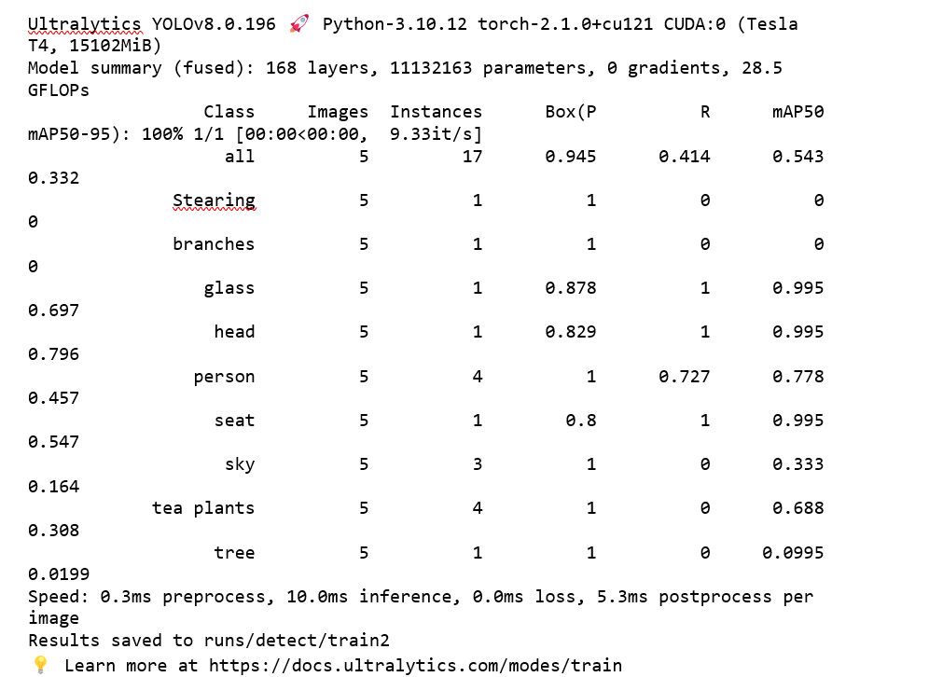

Since the mAP for the listed class in the above image for 6/9 is above 0.5 to 0.995 and it is clearly stating that there is High Precision and Low Recall
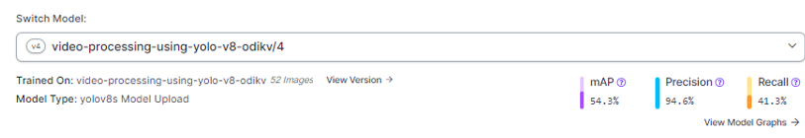
- A high precision indicates that when the model predicts a positive class, it is likely correct. The model gives 94.6% as Precision value which indicates that the objects in the video predicted by out model is correct
- A low recall (41.13%) suggests that the model is missing a significant portion of the positive instances.
- mAP being at 54.13% is decent, but what is considered a good mAP can depend on the specific application and dataset.

Hence, the model seems to have high precision, meaning it's good at avoiding false positives. However, it sacrifices recall, suggesting that it misses a notable portion of the positive instances. The mAP is an overall measure combining precision and recall across different levels. The interpretation of these metrics depends on the specific goals and requirements of the task.

REFERENCES:
Skalski, P. (2023, October 24). Train YOLOv8 on a Custom Dataset. Roboflow Blog. https://blog.roboflow.com/how-to-train-yolov8-on-a-custom-dataset/
R. (n.d.). notebooks/notebooks/train-yolov8-object-detection-on-custom-dataset.ipynb at main · roboflow/notebooks. GitHub. https://github.com/roboflow/notebooks/blob/main/notebooks/train-yolov8-object-detection-on-custom-dataset.ipynb
Roboflow: Give your software the power to see objects in images and video. (n.d.). https://roboflow.com/
Kundu, R. (2023, April 20). YOLO: Algorithm for Object Detection Explained [+Examples]. V7. https://www.v7labs.com/blog/yolo-object-detection
Shah, D. (2023, April 24). Mean Average Precision (mAP) Explained: Everything You Need to Know. V7. https://www.v7labs.com/blog/mean-average-precision

VIDEO DRIVE LINK:
https://drive.google.com/file/d/10MGbrYKsCL7NvAftEI4GZ_1iCsDkO6mk/view?usp=sharing

ROBOFLOW PROJECT LINK:
https://universe.roboflow.com/s-hariharan/video-processing-using-yolo-v8-odikv

THANK YOU

